Gender Pay Reporting

For the period ending 5th April 2024

INEOS FPS Ltd.

Gender Pay Report 2024 INEOS FPS Ltd

The Forties Pipeline System (FPS) is an integrated oil and gas liquid transportation and processing system serving the central area of the North Sea. It is owned and operated by INEOS and utilises more than 500 miles of pipeline to smoothly transport crude oil and gas from more than 80 offshore fields for processing at the Kinneil Terminal where the oil and gas transported is separated.

The oil is returned as Forties Blend to customers or can be routed directly to the Grangemouth refinery. The separated gas is either delivered to our LPG export facilities or can be supplied to the petrochemicals processing facilities at Grangemouth.

We aim to establish and maintain a working environment where all employees are treated fairly and equally, ensuring equal opportunities for all. We value our employees and appreciate the benefits of having an inclusive and diverse workforce.

 | Mean gender pay gap | The difference between the mean hourly rate of pay of male full-pay relevant employees and that of female full-pay relevant employees
 | Median gender pay gap | The difference between the median hourly rate of pay of male full-pay relevant employees and that of female full-pay relevant employees
 | Mean bonus gap | The difference between the mean bonus pay paid to male relevant employees and that paid to female relevant employees
 | Median bonus gap | The difference between the median bonus pay paid to male relevant employees and that paid to female relevant employees
 | Bonus proportions | The proportions of male and female relevant employees who were paid bonus pay during the relevant period
 | Quartile pay bands | The proportions of male and female full-pay relevant
This report is based on data as at April 2024, looking at hourly pay as defined in the regulations. This includes base pay and allowances and any bonuses paid in the 12 months ending the 5th April 2024.

Demographics
475 Employees
77 (16.2%) 398 (83.8%)
The split of male and female employees is broadly unchanged from the previous year’s report.

Pay

The gender pay gap calculates the difference between average male and female pay within the organisation. It does not compare pay received by men and women doing the same or similar work which is referred to as equal pay.

Our technician pay structure and our job evaluation process provide us with a stuctured framework with which to evaluate roles and to group employees within appropriate salary ranges providing a non-discriminatory pay system.

Difference between gross hourly earnings
Mean | Median
16.67% | 14.66%

Pay Quartiles

Pay quartiles are calculated by splitting all employees in an organisation into four even groups according to their level of pay. Looking at the proportion of women in each quarter gives an indication of women's representation at different levels of the organisation. The proportion of male and females in each pay quartile is shown below. During this report period we have increased the proportion of women in the middle and upper quartiles of the organisation.

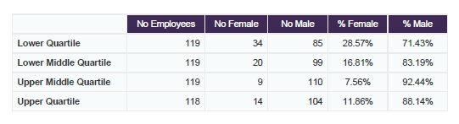

Whilst women make up only 16% of our employees, they are under-represented in the upper higher groups which is primarily occupied with management and senior engineering positions. This will be an area of focus for the future but it is likely to take some time for any changes to feed through.

The proportion of new female hires during the reporting year was 26%.

Within the lower quartile there is a greater gender balance as fewer roles within this quartile are directly linked to STEM activities.

Bonus

The majority of staff who were were employed during this review period were eligible for an annual business bonus although staff who joined the Company between the end of 2023 and the end of the relevant pay period do not qualify for a bonus payment.

Proportion of staff receiving a bonus
Female | Male
64.94% | 76.88%

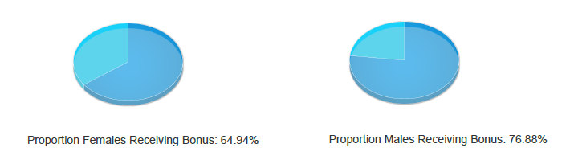

Difference between bonus pay
Mean | Median
-3.5% | -65.4%

The difference in mean bonus pay is reflective of the distribution of female employees across each pay quartile.

Population groups within the business can have different bonus opportunities and in the reporting year, the median female bonus was higher than the median male bonus. The median bonus reflects the middle ranking bonus payment and for the period being reviewed

Going Forward ……

As an organisation we are confident that our existing policies regarding recruitment, reward, maternity and flexible working all contribute to our ability to attract and retain women within our organisation and early indications for the next reporting year show that progress is being made in the recruitment balance.

We will continue and extend the work we do with local schools to promote and encourage a more balanced take up of STEM curriculum subjects.

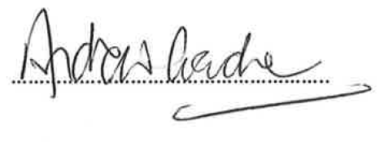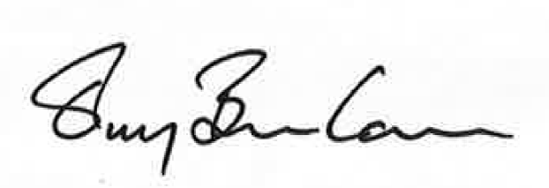
………………………………………………..

Declaration  I confirm that our data has been calculated according to the requirements of the Equality Act 2010  (Gender Pay Gap Information) Regulations 2017.  Andrew Gardner, CEO INEOS FPS | Declaration  I confirm that our data has been calculated according to the requirements of the Equality Act 2010  (Gender Pay Gap Information  Terry Banham, HR Director, INEOS FPS

