**GENDER PAY REPORTING**

**INEOS Chemicals Grangemouth Ltd**

**March 2024**

**Gender Pay Report 2023  
Ineos Chemicals Grangemouth Ltd**

INEOS Chemicals Grangemouth Ltd (ICGL) operates on one of the largest industrial complexes in Scotland. The site has a long history of innovation and development. It has benefitted from recent investments by INEOS, designed to ensure the preservation of sustainable UK/ Scottish manufacturing and the high value jobs that our operations support, both directly and indirectly.

These investments continue as we deliver on our road map and focus on a just transition to Net Zero manufacturing operations by 2045. And this is vital because our products are used as the building blocks in a multitude of applications which both enable and enhance many aspects of modern life today. These raw materials are transformed into housing and construction materials, cabling and insulation, automotive components, fibres and textiles, food packaging as well as being extensively used in the pharmaceutical and healthcare industry. In the drive for a sustainable future that will benefit all, our products help other sectors to reduce their carbon footprints too: ‘lightweighting’ materials and vehicles, longer shelf-lives and reducing food waste for example.

We aim to establish and maintain a working environment where all employees are treated fairly and equally, ensuring equal opportunities for all. Skills Development is high on our ‘agenda’ with opportunities for current colleagues to grow their skills and experiences through focussed training and career opportunities, whatever their role and position in the organisation, resulting in secure and fulfilling careers. We value our employees and appreciate the benefits of having an inclusive and diverse workforce.

Under UK Legislation businesses with more than 250 employees are required to publish data about their gender pay gap.

The regulations require us to report on: -

|  |  |
| --- | --- |
| **Mean gender pay gap** | The difference between the mean hourly rate of pay of male full-pay relevant employees and that of female full-pay relevant employees |
| **Median gender pay gap** | The difference between the median hourly rate of pay of male full-pay relevant employees and that of female full-pay relevant employees |
| **Mean bonus gap** | The difference between the mean bonus pay paid to male relevant employees and that paid to female relevant employees |
| **Median bonus gap** | The difference between the median bonus pay paid to male relevant employees and that paid to female relevant employees |
| **Bonus proportions** | The proportions of male and female relevant employees who were paid bonus pay during the relevant period |
| **Quartile pay bands** | The proportions of male and female full-pay relevant employees in the lower, lower middle, upper middle and upper quartile pay bands |

This report is based on a data as of April 2023, looking at hourly pay as defined in the regulations. This includes base pay, allowances and pro-rated bonuses paid in the 12 months ending the 5th April 2023.

**Demographics**

**572 Full Pay Relevant Employees**

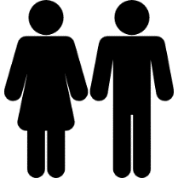

**121 (21%) 451 (79%)**

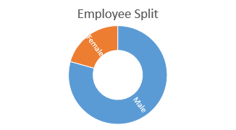

**Pay**

The gender pay gap relates to differences in average male and female pay within the organisation. It does not compare pay received by men and women doing the same or similar work, this is known as equal pay. Our technician pay structure and our robust job evaluation process provide us with a disciplined framework with which to evaluate roles and to group employees within our salary ranges providing a non-discriminatory pay system.

|  |  |
| --- | --- |
| **Difference between gross hourly earnings** | |
| **Mean** | **Median** |
| 9.21% | 8.09% |

Our evaluation, indicates that the difference in average pay is a due primarily to having proportionately more men than women in senior, higher paid roles.

**Pay Quartiles**

The proportion of male and females in each base pay quartile is shown below.

|  |  |  |
| --- | --- | --- |
| **Quartile** | **Male** | **Female** |
| Upper | 82.27% | 17.73% |
| Upper Middle | 84.93% | 15.07% |
| Lower Middle | 84.51% | 15.49% |
| Lower Quartile | 64.08% | 35.92% |

Women make up 21% of our employees but are under-represented in the upper and middle quartiles. The upper quartile and upper middle groups are primarily occupied with management and senior engineering positions.

This spread is consistent with many other businesses in our sector, particularly those businesses associated with Science, Technology, Engineering and Mathematics (STEM) where there are proportionately fewer women entering the sector at graduate level. Within the lower quartile there is a greater gender balance. The roles within this quartile are typically associated with administration and clerical posts.

**Bonus**

|  |  |
| --- | --- |
| **Proportion of Staff receiving a bonus** | |
| **Male** | **Female** |
| 75.6% | 76.61% |

|  |  |
| --- | --- |
| **Difference between Bonus Pay** | |
| **Mean** | **Median** |
| 17.5% | 22.79% |

As with pay, the bonus mean is heavily influenced and reflective of the fact that the majority of senior graded staff are male.

**Going Forward ……**

As a major manufacturer and employer in the region we recognise the important role we can play in addressing a rebalance of gender representation in our Sector. We have a long tradition of partnership working, with common goals of actively encouraging females into our industry and into STEM-related businesses. Our well-established employee network of positive role models support and champion the work undertaken by females, interacting with pupils and students at events specifically designed to highlight the opportunities available to women.

We firmly believe that our existing policies regarding recruitment, reward, maternity and flexible working already contribute to our ability to attract and retain women within our organisation.



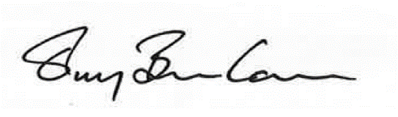

|  |  |
| --- | --- |
| **Declaration**  I confirm that our data has been calculated according to the requirements of the **Equality Act 2010**  (Gender Pay Gap Information) Regulations 2017.  Stuart Collings, CEO | **Declaration**  I confirm that our data has been calculated according to the requirements of the **Equality Act 2010**  (Gender Pay Gap Information) Regulations 2017.  Terry Banham, HR Director |